After the hardware setup (refer section:Getting Started), follow the subsequent steps to run the AWS KINESIS video streaming application. Use any serial port terminal application such as GTKTerm to issue the commands on T31z INP3201 Host.

**Note**: The video streaming set-up supports streaming from a single web connection/browser at a given time.

**Method 1: Manual Setup**

1. Insert the kernel modules using the following command:

|  |
| --- |
| insmod mmc_detect_test.ko  insmod sdio-wlan.ko |

1. Start the tunadapter in the background.

|  |
| --- |
| ./tunadapter board_conf=t31_innophase.conf & |

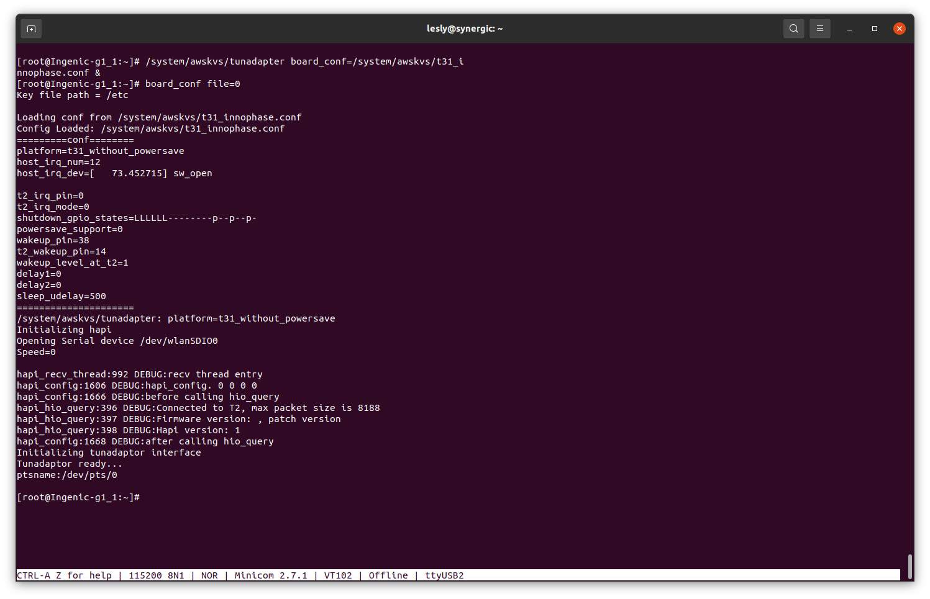

Figure 1: Start tunadapter

1. Connect Talaria TWO to an Access Point. This can be achieved using either one of the following methods:
   1. Execute the following set of commands:
      1. Start provisioning:

|  |
| --- |
| ./conmgr provstart <device_name> <manufacturer_name> |

* + 1. Get provisioning information (SSID and passphrase of the Access Point):

|  |
| --- |
| ./conmgr waitforprovinfo |

* + 1. Stop provisioning:

|  |
| --- |
| ./conmgr provstop |

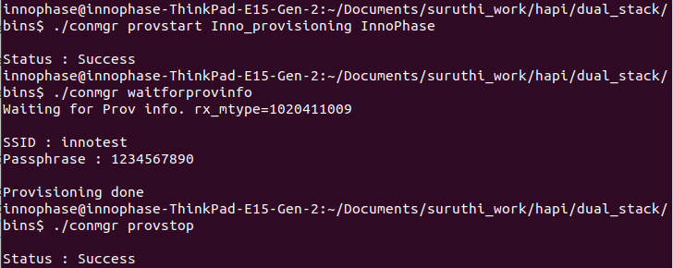

Figure 2: Enabling Wi-Fi provisioning over BLE

**Note**: <device_name> will be visible in the BLE scan list on the mobile app.

* 1. Enable Wi-Fi provisioning over BLE using the AWS_Streaming APP. It can be used to enable Wi-Fi provisioning over BLE and stream video.

For more details on passing the SSID and passphrase through the AWS_Sreaming mobile app, refer section: *Running the Application using Android or iOS app* from *Example_using_Provisioning.pdf* (*freertos_sdk_x.y\examples\prov\doc*).

**Note**: x and y in freertos_sdk_x.y refer to the SDK package release version.

* 1. **Alternate method**: Pass the SSID and passphrase of the appropriate AP by executing the following command:

|  |
| --- |
| ./conmgr connect <ssid> <password> |

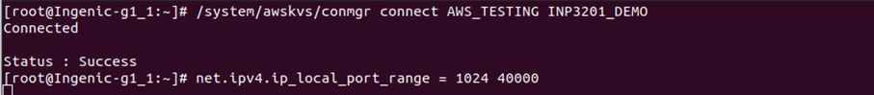

Figure 3: Connect to AP

1. Run the NTP service from T31z host:

|  |
| --- |
| [root@Ingenic-g1_1:ces_master]# ntpd -nqp pool.ntp.org |



Figure 4: Run NTP service

1. To start the video streaming, insert kernel modules and start RTSP server on T31z host:

|  |
| --- |
| insmod /lib/modules/tx-isp-t31.ko  insmod /lib/modules/sensor_gc2053_t31.ko data_interface=1  insmod /lib/modules/avpu.ko clk_name='vpll' avpu_clk=400000000  insmod /lib/modules/audio.ko |

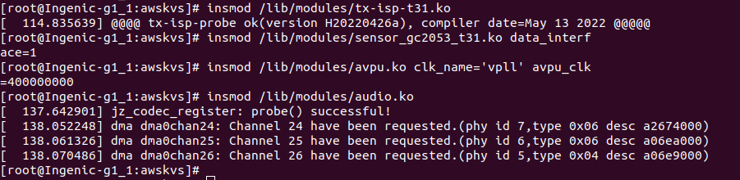

Figure 5: Insert ko modules

1. The following script configures the AWS access key, secret access key, region and starts streaming:

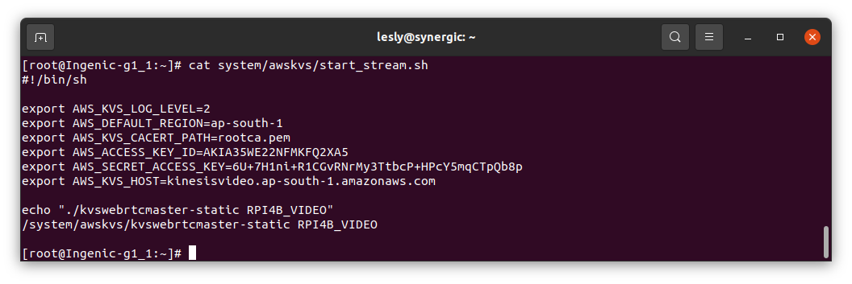

Figure 6: Start kinesis video streaming

**Note**: For information on creating the AWS security credentials (access key, secret access key), refer Create AWS Security Credentials.

**Method 2 – Automated Shell Scripts**

1. Execute the init script file to automatically load kernel drivers, connect Wi-Fi, and start the AWS KINESIS Video Streaming after booting.

**Note**:

* + 1. Change the SSID and passphrase in app_init.sh to the required configuration.
    2. Steaming duration is configurable. Modify the same in app_init.sh for the required duration.

Use Delay=0 for uninterrupted streaming without entering the low-power mode.

|  |
| --- |
| ./T31_mcu_app <Delay 0 to 300 sec> <Trun OFF devices 1= T31, 3= T31 & T2 > |

* + 1. Configure Talaria TWO Wi-Fi wakeup from MCU.

|  |
| --- |
| ./conmgr wakeupconfig <T2 wakeup GPIO pin> <GPIO level> <GPIO direction 0=output / 1= input> |

* + 1. Configure MCU wakeup from Talaria TWO.

|  |
| --- |
| ./conmgr wakeupconfig <MCU wakeup GPIO pin> <GPIO level> |

* + 1. Initialize the MQTT connection.

|  |
| --- |
| ./sc scinit <server name> <port number> <tranport> <mqtt id> <usr name> <password> [ca cert] [client cert] [client key] |

* + 1. Close the MQTT connection.

|  |
| --- |
| ./sc scdeinit |

* + 1. Update the streaming status.

|  |
| --- |
| ./sc scstatusupdate < status : 1/0 > |

where,

1- ON, 0 - OFF

app_init.sh script for INP3201 board with MCU loads the required kernel driver modules, starts the MQTT connection and turns the camera ON. Kinesis video streaming is then started for a specified time. The device is put to sleep mode in case of inactivity on the PIR sensor connected to the MCU.

**Note**: To put the INP3201 board with MCU in low-power mode, execute the following steps:

* + 1. Start tunadapter in the background and connect to the AP:

|  |
| --- |
| ./tunadapter board_conf =./t31.conf &  ./conmgr connect <ssid> <Pass> |

* + 1. Initiate Host shutdown:
       1. Provide the number of seconds for which streaming needs to be enabled:

|  |
| --- |
| ./T31_mcu_app <Delay> 1 |

* + - 1. Configure the Host wakeup PIN:

|  |
| --- |
| ./conmgr wakeupconfig 14 1 1  ./conmgr wakeupconfig 21 0 |

**Note**: For more information on configuring the Host wakeup PIN, refer section: *wakeupconfig – Configures Host Wakeup PIN* of UG_Dual-Stack.pdf (*\talaria_two_dual_stack\talaria_two_dual_stack_vx.y\doc*)

* + - 1. Get the previous wakeup reason:

|  |
| --- |
| ./conmgr getwakeupreason |

* + - 1. Clear wakeup reason before initiating shutdown:

|  |
| --- |
| ./conmgr wakeupreasoncls |

* + - 1. Trigger Host shutdown:

|  |
| --- |
| ./conmgr shutdown |

1. The following script configures the AWS access key, secret access key, region and starts streaming:

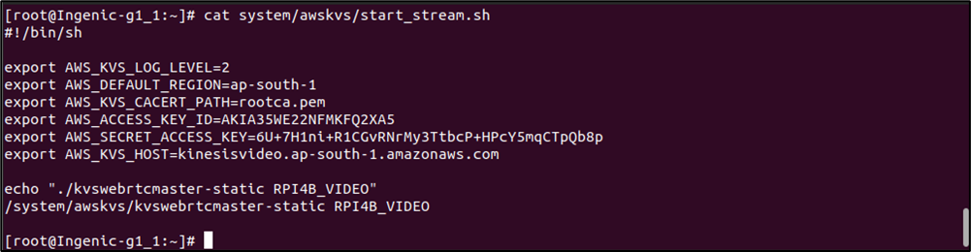

Figure 7: Script to configure AWS access parameters

**Note**: For information on creating the AWS security credentials (access key, secret access key), refer Create AWS Security Credentials.